Regardless of the type of API you are interacting with, and which approach it takes to change management, deprecation is going to be an important part of keeping up with the change. Any time a change is not just additive, deprecation will be used to communicate a breaking change.
Deprecation is the art of telling people to stop using a thing, because that thing is probably going away at some point. Even if there are no solid plans to delete the thing entirely, the thing might be deprecated just because it sucks to work with, but usually it’s because it has been replaced with a better idea.
Sadly there are no promises the team in charge will deprecate things cautiously. Some API providers act like jerks and just arbitrarily change things, remove things, and break stuff. Closing APIs down with no warning (or poor warning) is utterly disgraceful behavior, but it does happen. Facebook especially like to pull the rug out on their API users. Sometimes breaking changes are introduced accidentally.
Usually a more reasonable approach is taken, and API providers will communicate change in a variety of ways. There are a few common methods to keeping up with the changing happening to an API integrated into your codebase.

Low-Tech General Solutions
As ludicrous as it might sound, the entire extent of some API providers attempts to communicate upcoming change is “write a blog about it and hope you notice.”
These blog articles explain things like “Hey we’re closing off the free access to this API”, or “We are replacing this Foo API with a Bar API, and you have 3 months to stop using the Foo API before we shut it down”. Fingers crossed you see it!
This low-tech approach has no real solutions I can think of, other than… subscribe to the api providers engineering blog on RSS, and - so long as the RSS reader you’re using doesn’t get shut down - you might notice the article. If they have a newsletter then subscribe to that, maybe with a ”devs@” email address or team-specific email address, to improve the bus factor on this. You don’t want the announcement going to a member of the team who’s quit, then the API breaks just because the rest of the team didn’t know about the change.
APIs requiring authentication will usually ask for an email address in return for the authentication credentials (API keys, access tokens, etc.) This gives API providers one more way to get in touch about change, and again, make sure it’s not the email of a manager or team lead, but a distribution email address for the team.

REST / Endpoint-based APIs
If an API is using global versioning, then they might deprecate all the endpoints under /v1/ at the same time, and suggest you use all the /v2/ endpoints. If they’re using evolution they might suggest that /companies is going away, and you should start to work with /accounts instead. The suggestions here may come in the form of low-tech announcements, but they can also be communicated in-band.

Deprecated Endpoints
There is a a proposed standard: Sunset Header, which at the time of writing is at draft 05. APIs can add a simple header to the HTTP response, to let clients know the endpoint is nearing the end of its life.
Supporting Sunset is as simple as sniffing for the sunset header, and it contains a HTTP date which looks a little like this:

Sunset: Sat, 31 Dec 2018 23:59:59 GMT
The proposed standard also allows responses to contain a HTTP link header, with rel=sunset. The link can be a link to anything, the endpoint replacing it, a link to some human readable documentation, a blog post, whatever.
Keep an eye out for sunset headers and their accompanying links coming back in responses your code is getting, and log, or alert, or pass to a dashboard accordingly. If you are using Ruby or PHP there are already easy to use middleware for the most popular HTTP clients:
- PHP: hskrasek/guzzle-sunset
- Ruby: wework/faraday-sunset
Sunset is on GitHub, and the issue tracker is used for discussion around it's development. Some API gateways like Tyk are building in support, and it is going to become far more wide-spread over time. If you make an implementation for your favorite HTTP client please get in touch with @apisyouwonthate on Twitter.
Another approach commonly used by API providers is to provide SDKs, and if they are kept up to date they will fling out deprecation warnings about resources that are going away.
When you get these notifications, check the errors for what to do next, or go to their documentation to figure it out, or shout at their customer support for not making it clear what you’re meant to be doing next and they’ll do a better job next time.

Deprecating Properties
Other than the entire endpoint going away, specific properties may over time be deprecated. This is less common in global versioning as they would just remove those in the next global version. It is not a regular occurrence in evolution as they too would just wait until the creation of a new resource for the concept, but it can happen if a property absolutely has to go away.
JSON is the main content type in use these days, which does not have a type system built in. There is no way to mark a JSON field as deprecated in just JSON, and no standards exist to help, even JSON Schema still has this on the todo list.
Again SDKs can mark things as deprecated over time, especially those built with OpenAPI v3.0.0 or later. OpenAPI added the deprecated: true keyword, so SDKs can now look for this and fire off deprecation warnings for clients using that property in their code. Keeping up to date is important, so make sure something like Snyk or Greenkeeper is implemented to keep tabs on dependencies.

GraphQL
GraphQL pushes hard for evolution in its marketing and most advice in the ecosystem, which is awesome. They do not have a huge amount of documentation covering deprecations, and much of it comes from third-parties like Apollo, but it’s certainly possible.

Deprecating Types
Instead of endpoints, GraphQL has types. There is no first class support for deprecating types in GraphQL at the time of writing, so an API developer is unable to evolve the concept through adding new properties, a new type will pop up somewhere. A low-tech solution like a blog or email announcement may be used to communicate this new type, and the deprecation of the old type, as there is no way to do it in band. Another solution is to deprecate all the properties in the type, and mark in the reason that the whole type is going away.

Deprecating Properties
The API provider will add the @deprecated keyword to the type:

type User {
name: String @deprecated(reason: “Property ’name’ was split into ‘firstname’ and ‘lastname’”)
firstname: String
lastname: String
}
When looking at a GraphQL API through GraphiQL, the documentation that it autogenerates will show deprecated fields, visually separated from the other fields (smart!)
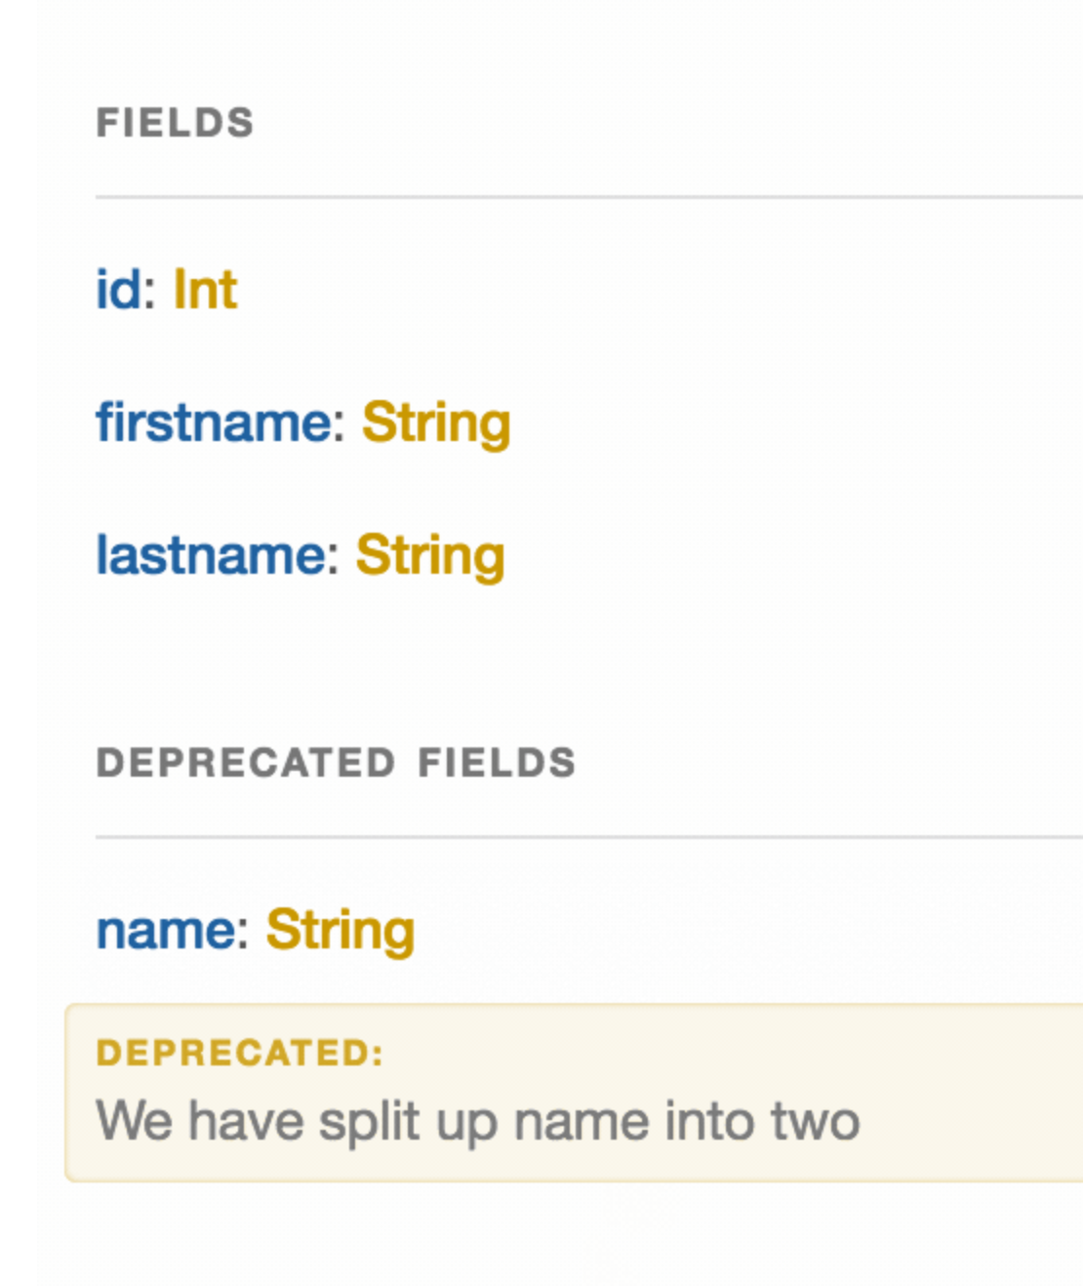
This image is from Kevin Simper’s awesome article: How to deprecate fields in GraphQL.

